

My Target: ____ / or ______ %

🖒 🖓 (Circle when your task is handed back)

NAME:

Due date:

Year 8 HASS, Geography

Task 2

Part A: Geomorphic Hazards Information Inquiry Booklet (5%) (40 marks)

Part B: Geomorphic Hazards Brochure (2.5%) (18 marks)

Part C: In-class validation test (2.5%)

Summary of task:

Your task is to develop an information brochure that promotes community awareness about a chosen geomorphic hazard (earthquake).

You will explore a selected geomorphic hazard (earthquake) in detail in class and use research time, both at school and at home, to compile relevant information.

You will use research skills to find information that answers the following focus questions:

1. Define what an earthquake is. (What is an earthquake?)
2. Outline where earthquakes occur. (Where do earthquakes occur?)
3. Outline the causes earthquakes? (What causes earthquakes?)
4. Outline the effects of earthquakes on people (social). (What are the effects of earthquakes on people?)
5. Outline the effects of earthquakes on the environment. (What are the effects of earthquakes on the environment?)
6. Outline the effects of earthquakes on the economy. (What are the effects of earthquakes on the economy?)
7. Outline what people can do to prepare for an earthquake (planning, community education, information management, communications and warning systems). (What can people do to prepare for an earthquake?)
8. An additional question created by the student.

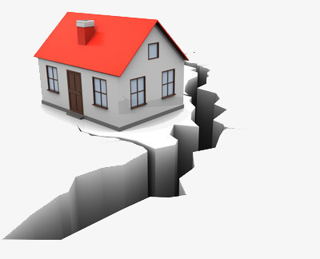

Your notes must provide examples and supporting evidence throughout your responses.

This assessment is in three parts:

Part A: Inquiry Booklet (5%)

You are to use internet, book and library resources to conduct research into the selected geomorphic hazard (earthquake). You must also complete a bibliography list recording the references used to find information.

**Part B: Information Brochure (2.5%)**

Your information brochure must clearly provide information to people about how to prepare, and what to do in the event of an earthquake. The brochure must include information that you have found during the research process.

**Part C: In-class validation (2.5%)**

You will have an in-class validation test on the knowledge you have learnt from the inquiry. The test will be closed-book and under timed conditions.

**Part A: Inquiry Booklet**

1. Use the space below to brainstorm what you already know about the topic. **(4 marks)**

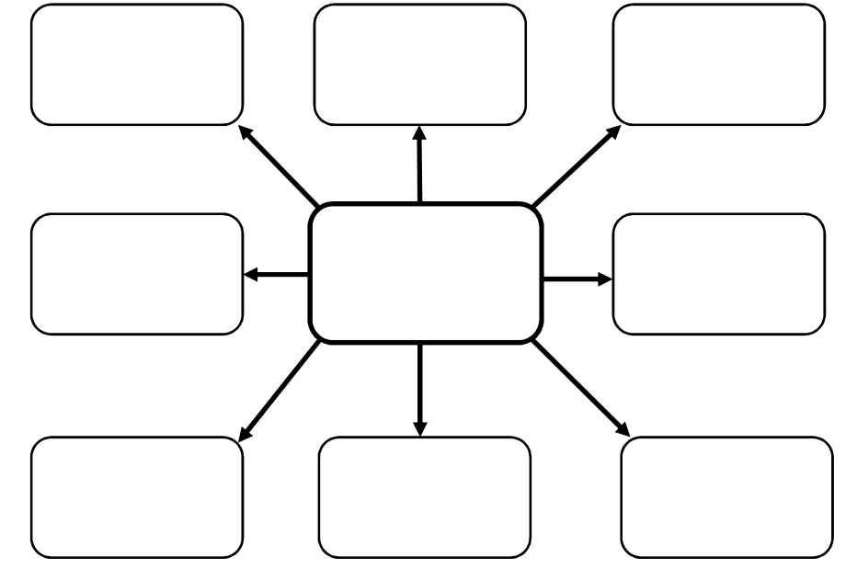

1. Notetaking: use the focus questions to find information about earthquakes.  **(24 marks)**

|  |  |
| --- | --- |
| Focus question 1: | Focus question 2: |
|  |  |

|  |  |
| --- | --- |
| Focus question 3: | Focus question 4: |
|  |  |

|  |  |
| --- | --- |
| Focus question 5: | Focus question 6: |
|  |  |

|  |  |
| --- | --- |
| Focus question 7: | Focus question 8: |
|  |  |

|  |  |  |  |  |  |
| --- | --- | --- | --- | --- | --- |
| **Author** | **Date last updated** | **Title of Webpage** | **Date accessed** | **HTTP** | |
|  |  |  |  |  | |
|  |  |  |  |  | |
|  |  |  |  |  | |
|  |  |  |  |  | |
|  |  |  |  |  | |
|  |  |  |  |  | |
| **Author** | **Date of Publication** | **Title of Book** | **Publisher** | | **Place of Publication** |
|  |  |  |  | |  |
|  |  |  |  | |  |
|  |  |  |  | |  |

1. **Reference recording sheet**

*Please note that in order to obtain full marks you must submit a formal bibliography; the table below is only for recording your references as you are researching.*

|  |  |  |  |  |  |
| --- | --- | --- | --- | --- | --- |
| **Author** | **Date last updated** | **Title of Webpage** | **Date accessed** | **HTTP** | |
|  |  |  |  |  | |
|  |  |  |  |  | |
|  |  |  |  |  | |
|  |  |  |  |  | |
|  |  |  |  |  | |
|  |  |  |  |  | |
| **Author** | **Date of Publication** | **Title of Book** | **Publisher** | | **Place of Publication** |
|  |  |  |  | |  |
|  |  |  |  | |  |
|  |  |  |  | |  |

1. Bibliography (6 marks)

Write out your references in full to create a formal bibliography. References should be written in alphabetical order according to the author. An example reference would look like this:

Book

C. Arends et al. 2017. Humanities and Social Sciences 8. Pearson, Melbourne, VIC.

Webpage

The Environment Foundation. 2018. What are earthquakes? Accessed 5/2/2019. <http://www.environmentguide.org.nz/issues/natural-hazards/earthquakes/what-are-earthquakes/>

Bibliography

1. Reflection **(6 marks)**

Please respond to the following four questions (*be specific)*:

I learnt …

|  |
| --- |
|  |
|  |
|  |
|  |
|  |
|  |

I was surprised …

|  |
| --- |
|  |
|  |
|  |
|  |
|  |
|  |

I wonder …

|  |
| --- |
|  |
|  |
|  |
|  |
|  |
|  |

Name:______________________________________________ My Target:_______/40 or _______%

**Year 8- Geography- Geomorphic Hazard information brochure (Inquiry Task)**

**DETAILED MARKING GUIDE/RUBRIC**

**PART A: INQUIRY BOOKLET (5%)**

|  |  |  |  |  |
| --- | --- | --- | --- | --- |
|  |  |  | **3-4** | **0-2** |
| **Brainstorm**  **/4** |  |  | Presents a very detailed and comprehensive brainstorm which clearly outlines prior knowledge on the chosen geomorphic hazard. | Presents a brainstorm which lacks detail and shows limited prior knowledge on the chosen geomorphic hazard. |
|  | **19-24** | **13-18** | **7-12** | **0-6** |
| **Note taking**  **/24** | Provides very detailed, comprehensive and accurate notes that address all focus questions on the geomorphic hazard. Notes address research areas in detail and has changed key points into full sentences effectively.  Uses evidence from a range of sources. | Provides generalised notes that address most of the focus questions on the geomorphic hazard.  Addresses research areas in some detail. Has constructed full sentences from key points though not always correctly. | Provides basic points notes that may or may not address the focus questions for the geomorphic hazard. Addresses research areas in limited detail. | Provides limited and/ or no notes. Does not complete this section.  No notes are submitted. (0) |
|  |  | **5-6** | **3-4** | **0-2** |
| **Bibliography**  **/6** |  | Collects information and images from a comprehensive number of sources and records a variety of key information which relates to the chosen geomorphic hazard, incorporating ethical protocols, which correctly follow the referencing technique approved by the school. | Bibliography includes a smaller range of sources which mostly follows the referencing technique approved by the school. | No bibliography submitted (0)  Bibliography includes a limited list of sources which may follow the referencing technique approved by the school, however, does not incorporate all requirements. |
|  |  | **5-6** | **3-4** | **0-2** |
| **Reflection**  **/6** |  | Completes all four sections of the self-reflection using full sentences and uses detailed examples. | Completes parts of the self-reflection using full sentences and uses some detailed examples. | Does not complete all sections of the self-reflection.  No self –reflection submitted(0) |
| **TOTAL**  **/40** |  | | | |

**PART B: BROCHURE (2.5%)** My Target:_______/18 or _______%

|  |  |
| --- | --- |
| **DESCRIPTION** | **MARKS** |
| **Earthquakes** | |
| Presents current information in a detailed and well‐organised manner (e.g. using appropriate frameworks, categories and charts). Constructs a brochure which is logical, easy to understand and shows a comprehensive understanding of the causes, occurrence, impacts and responses to a geomorphic hazard (earthquake); how the effects caused by geomorphic hazards (earthquake) are influenced by social, environmental and economic (SEE) factors; and how the prevention, mitigation and preparedness minimises the harmful effects of geomorphic hazards (earthquakes). | 7-9 |
| Presents information in an organised manner (e.g. simple frameworks, categories and charts). Constructs a brochure which shows a simple understanding of the causes, occurrence, impacts and responses to a geomorphic hazard (earthquake); how the effects caused by geomorphic hazards (earthquake) are influenced by social, environmental and economic (SEE) factors; and how the prevention, mitigation and preparedness minimises the harmful effects of geomorphic hazards (earthquakes). | 4-6 |
| Presents information and data in a basic manner. Information is not of a detailed nature and shows a limited understanding of the causes, occurrence, impacts and responses to a geomorphic hazard (earthquake); how the effects caused by geomorphic hazards (earthquake) are influenced by social, environmental and economic (SEE) factors; and how the prevention, mitigation and preparedness minimises the harmful effects of geomorphic hazards (earthquakes). | 1-3 |
| **Subtotal** | **/9** |
| **Layout of brochure** |  |
| The colour, shape, size and arrangement of images and information convey clear meaning of the overall message. The brochure is visually appealing to look at and information is clearly communicated. | 7-9 |
| The colour, shape, size and arrangement of images and information convey meaning to the overall message. The brochure is somewhat visually appealing to look at and information is mostly clearly communicated. | 4-6 |
| The colour, shape, size and arrangement of images and information convey some meaning to the overall message. Student has made an attempt to construct the brochure in a visually appealing way and has made an attempt to construct clear information. | 1-3 |
| **Subtotal** | **/9** |
| **TOTAL** | **/18** |

**Overall comment:**